**CC6012 – Tutorials**

**Get started with ASP.NET Core MVC**

*Sandra Fernando*

*LMU (2023-24)*

Part 1, Add a new web application 3

Part 2, add a controller to an ASP.NET Core MVC app 6

Part 3, add a view to an ASP.NET Core MVC app 11

Part 4, add a model to an ASP.NET Core MVC app 19

Part 5, work with a database in an ASP.NET Core MVC app 24

Part 6, controller methods and views in ASP.NET Core 28

Part 7, add search to an ASP.NET Core MVC app 31

Part 8, add a new field to an ASP.NET Core MVC app 37

Part 9, add validation to an ASP.NET Core MVC app 42

Part 10, examine the Details and Delete methods 45

Part 11 Simple authorization in ASP.NET Core 46

Part 12, Scaffold Identity into a Razor project 49

Reference 52

(The content is built using the Microsoft ASP.NET Documentation)

<https://learn.microsoft.com/en-us/aspnet/core/tutorials/first-mvc-app/start-mvc?view=aspnetcore-7.0&tabs=visual-studio>

Download – VS2022 community edition

<https://visualstudio.microsoft.com/vs/community/>

This tutorial series teaches ASP.NET Core MVC web development with controllers and views. If you're new to ASP.NET Core web development, consider the Razor Pages  version of this tutorial, which provides an easier starting point.

### ASP.NET Core Razor Pages

Razor Pages is a page-based model. UI and business logic concerns are kept separate, but within the page. Razor Pages is the recommended way to create new page-based or form-based apps for developers new to ASP.NET Core. Razor Pages provides an easier starting point than ASP.NET Core MVC.

Razor Pages benefits, in addition to the server rendering benefits:

* Quickly build and update UI. Code for the page is kept with the page, while keeping UI and business logic concerns separate.
* Testable and scales to large apps.
* Keep your ASP.NET Core pages organized in a simpler way than ASP.NET MVC:
  + View specific logic and view models can be kept together in their own namespace and directory.
  + Groups of related pages can be kept in their own namespace and directory.

# Part 1, Add a new web application

1. **Launch VS 2020, you will see the open screen. Click create new project.**

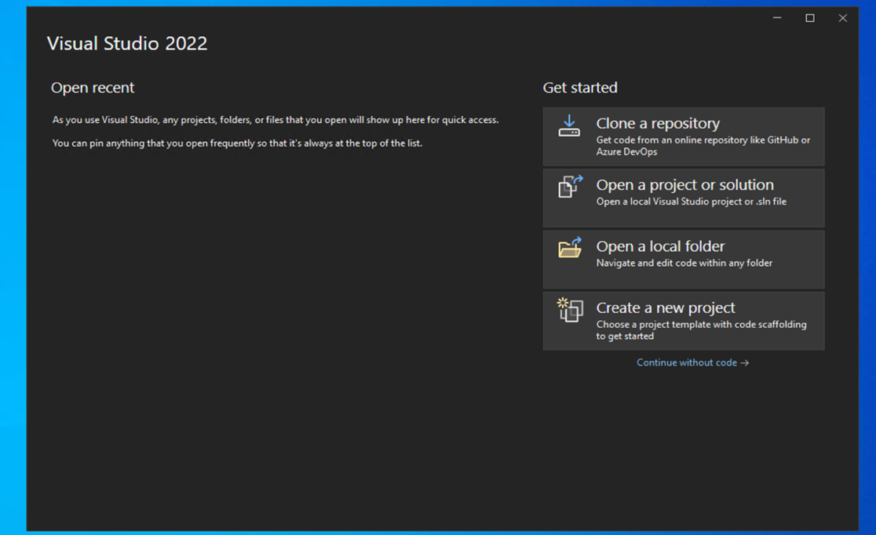

1. Type asp.net core Web App in the search box. Pick the highlighted list item **ASP.NET Core Web App(Model-View-Controller)that has C# language.** Click Next.

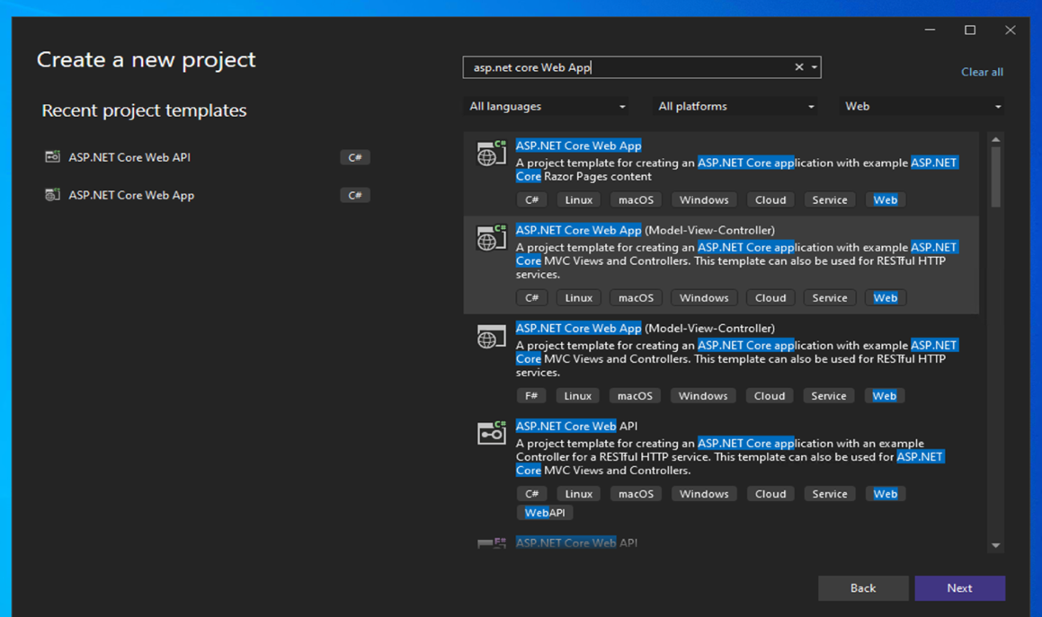

1. Next, Provide project name (**MvcMovie)**, choose a location you want Mvc projects to be saved and finally click place solution and project in the same directory.

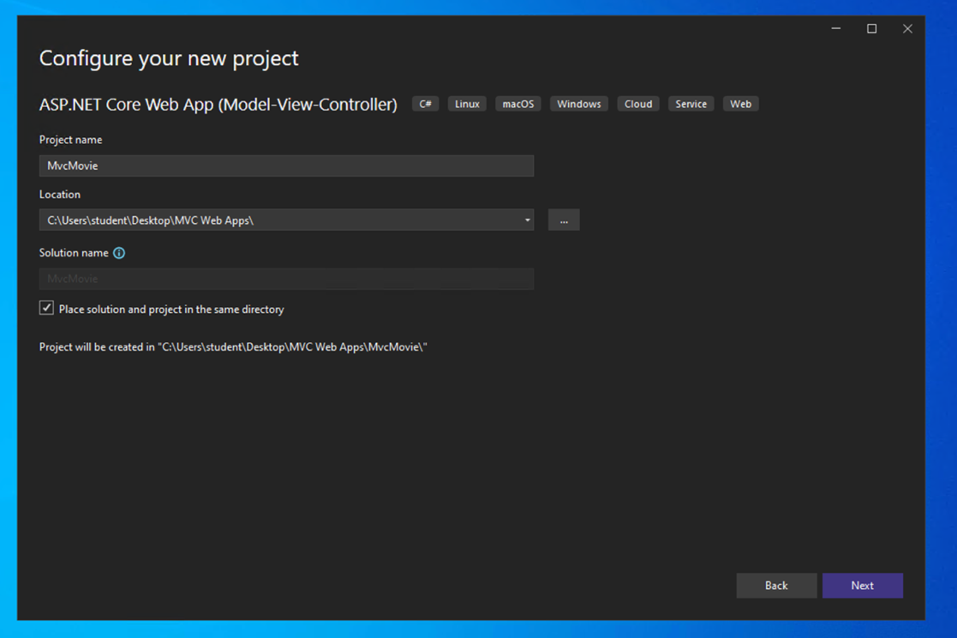

1. Next in the additional information, select the framework - **.NET 7.0** and authentication type – **Individual Accounts**.

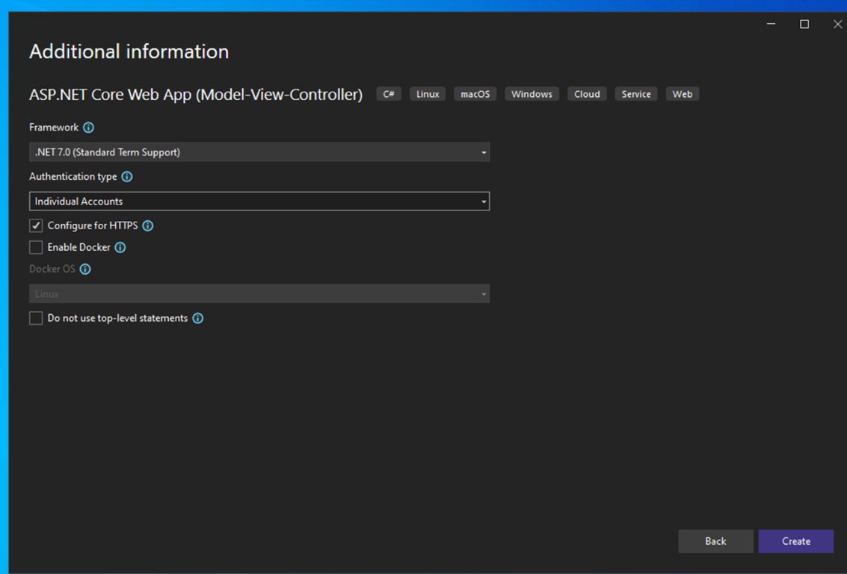

1. You will then see a project working area with server explorer, solution explorer, etc.

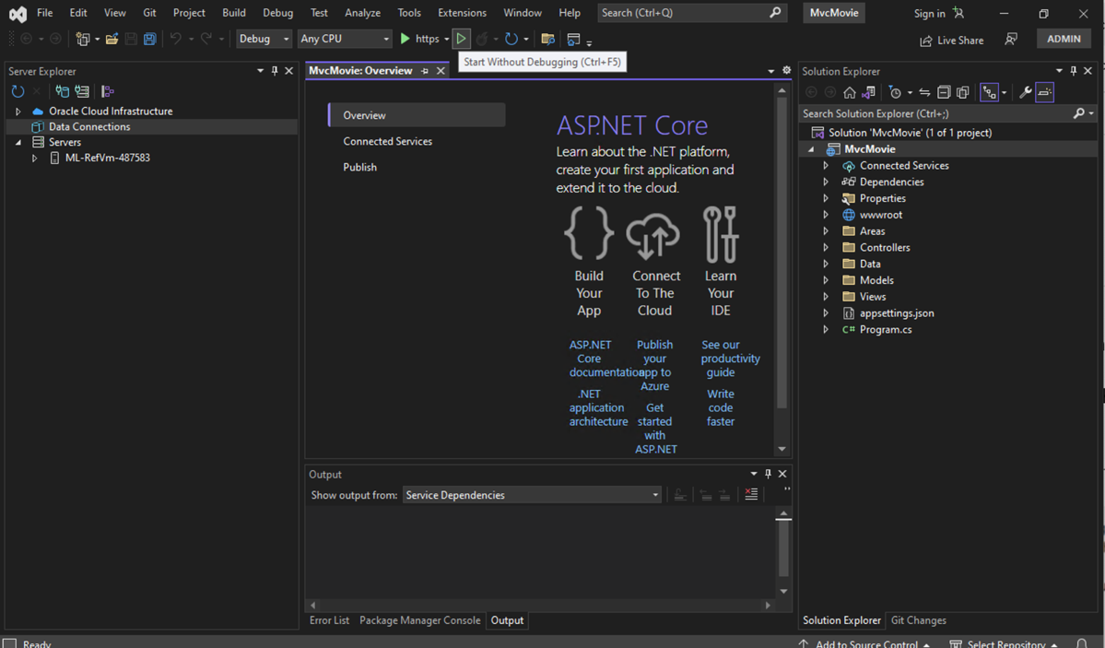

1. Finally run the application with (Ctl+5) or , by pressing the RUN button on the toolbar. You can say yes, to the SSL certificates message. And see the output webpage.

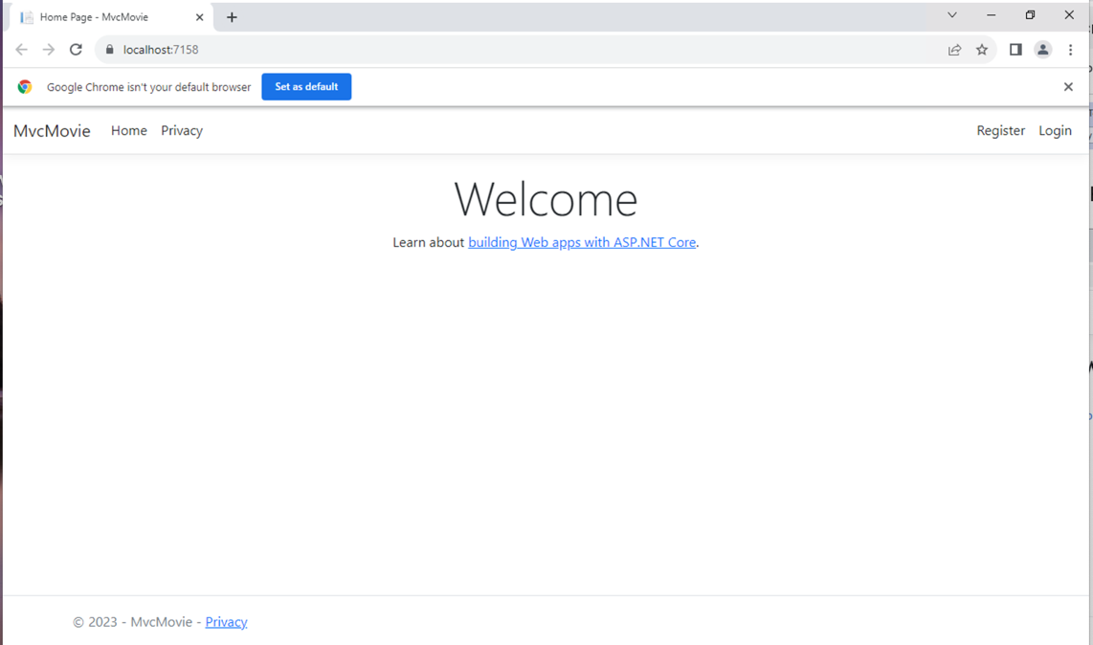

# Part 2, add a controller to an ASP.NET Core MVC app

The Model-View-Controller (MVC) architectural pattern separates an app into three main components: **M**odel, **V**iew, and **C**ontroller. The MVC pattern helps you create apps that are more testable and easier to update than traditional monolithic apps.

MVC-based apps contain:

* **M**odels: Classes that represent the data of the app. The model classes use validation logic to enforce business rules for that data. Typically, model objects retrieve and store model state in a database. In this tutorial, a Movie model retrieves movie data from a database, provides it to the view or updates it. Updated data is written to a database.
* **V**iews: Views are the components that display the app's user interface (UI). Generally, this UI displays the model data.
* **C**ontrollers: Classes that:
  + Handle browser requests.
  + Retrieve model data.
  + Call view templates that return a response.

In an MVC app, the view only displays information. The controller handles and responds to user input and interaction. For example, the controller handles URL segments and query-string values and passes these values to the model. The model might use these values to query the database. For example:

* https://localhost:5001/Home/Privacy: specifies the Home controller and the Privacy action.
* https://localhost:5001/Movies/Edit/5: is a request to edit the movie with ID=5 using the Movies controller and the Edit action, which are detailed later in the tutorial.

The MVC architectural pattern separates an app into three main groups of components: Models, Views, and Controllers. This pattern helps to achieve separation of concerns: The UI logic belongs in the view. Input logic belongs in the controller. Business logic belongs in the model. This separation helps manage complexity when building an app, because it enables work on one aspect of the implementation at a time without impacting the code of another. For example, you can work on the view code without depending on the business logic code.

These concepts are introduced and demonstrated in this tutorial series while building a movie app. The MVC project contains folders for the *Controllers* and *Views*.

**1 .** In Solution Explorer, right-click Controllers > Add > Controller. Make sure it is empty.

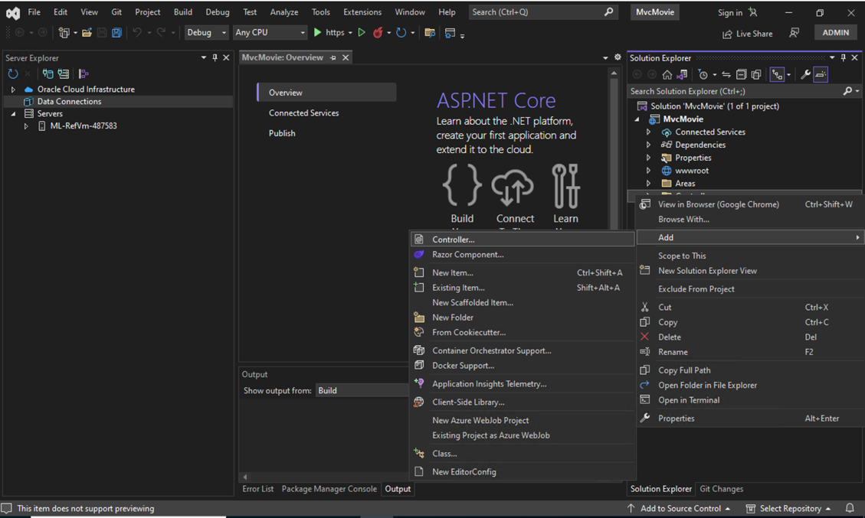

2. In the Add New Item - MvcMovie dialog, enter HelloWorldController.cs and select Add.

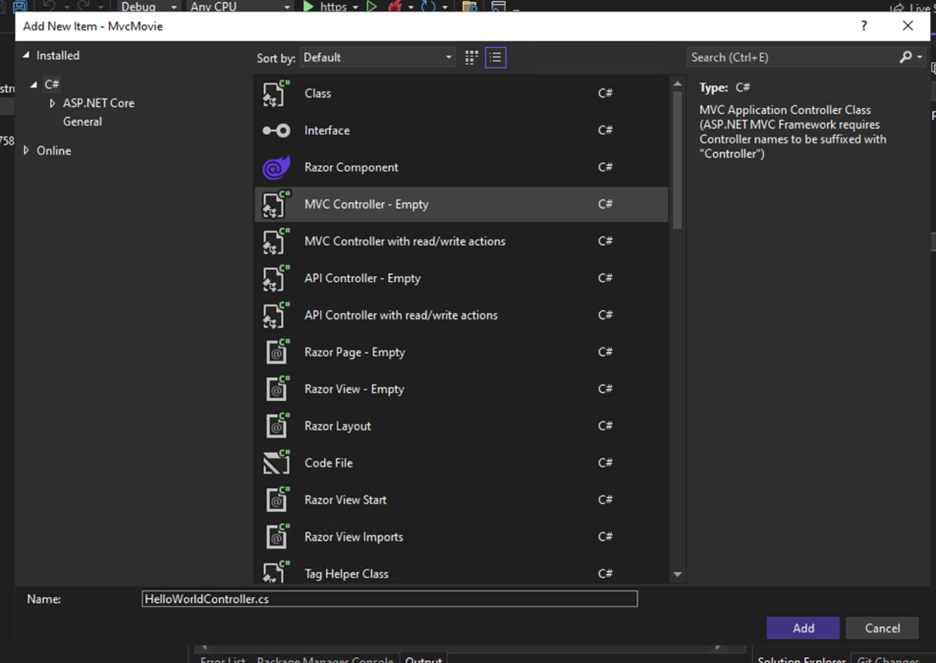

3. Replace the contents of Controllers/HelloWorldController.cs with the following code:

using Microsoft.AspNetCore.Mvc;

using System.Text.Encodings.Web;

namespace MvcMovie.Controllers;

public class HelloWorldController : Controller

{

//

// GET: /HelloWorld/

public string Index()

{

return "This is my default action...";

}

//

// GET: /HelloWorld/Welcome/

public string Welcome()

{

return "This is the Welcome action method...";

}

}

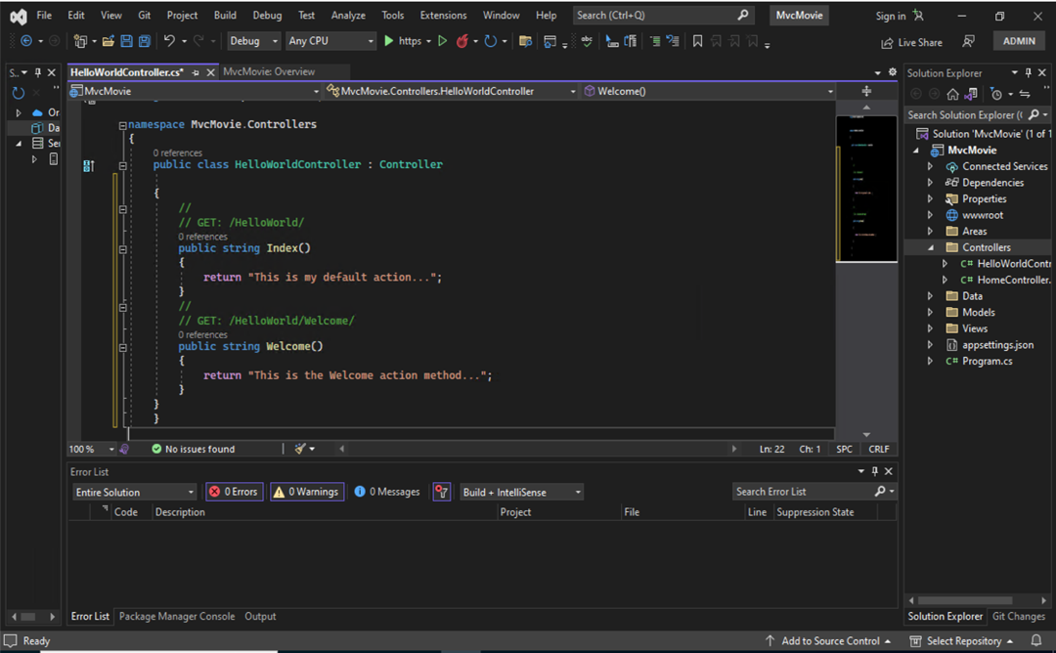

4. Run the app without the debugger.

Append /HelloWorld to the path in the address bar. The Index method returns a string.

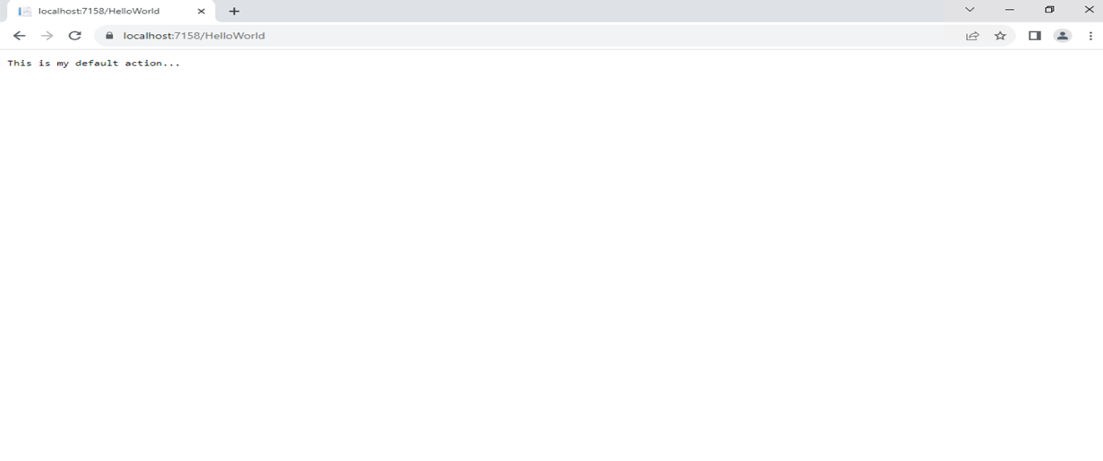

5. Change the Welcome method to include two parameters as shown in the following code.

// GET: /HelloWorld/Welcome/

// Requires using System.Text.Encodings.Web;

public string Welcome(string name, int numTimes = 1)

{

return HtmlEncoder.Default.Encode($"Hello {name}, NumTimes is: {numTimes}");

}

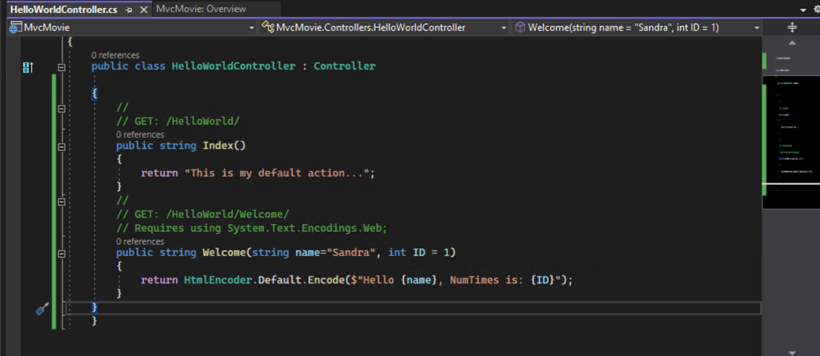

6. Run the app and browse to: https://localhost:{PORT}/HelloWorld/Welcome?name=Rick&numtimes=4. Replace {PORT} with your port number.

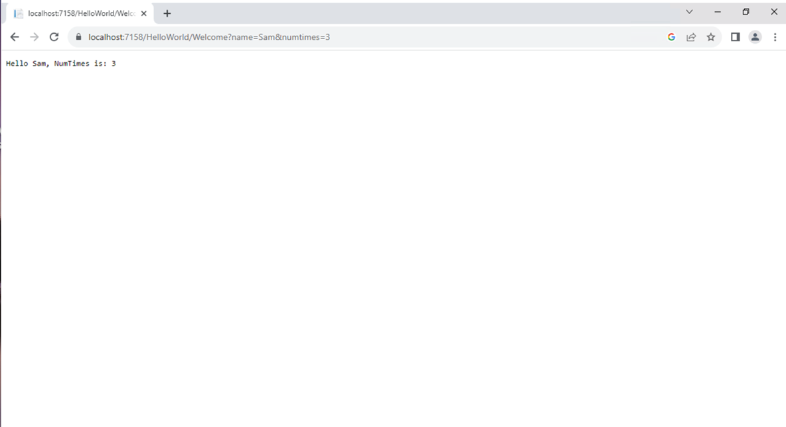

Try different values for name and numtimes in the URL. The MVC model system automatically maps the named parameters from the query string to parameters in the method.

# Part 3, add a view to an ASP.NET Core MVC app

In this section, you modify the HelloWorldController class to use Razor view files. This cleanly encapsulates the process of generating HTML responses to a client.

View templates are created using Razor. Razor-based view templates:

* Have a .cshtml file extension.
* Provide an elegant way to create HTML output with C#.

1. Change the HelloWorldController class with the following code.

public IActionResult Index()

{

return View();

}

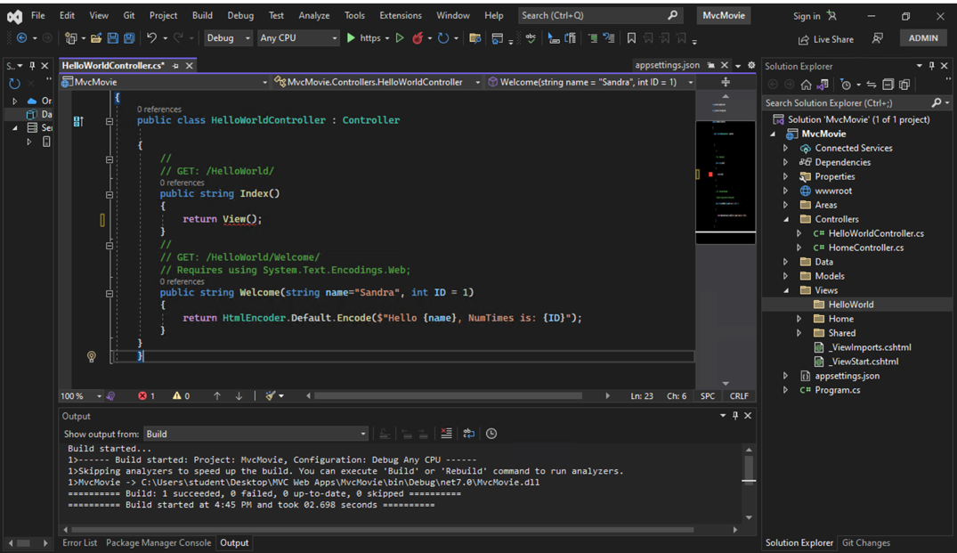

2. Add a view

Right-click on the Views folder, and then **Add > New Folder** and name the folder HelloWorld.

Right-click on the Views/HelloWorld folder, and then **Add > New Item**.

In the **Add New Item - MvcMovie** dialog:

* In the search box in the upper-right, enter view
* Select **Razor View - Empty**
* Keep the **Name** box value, Index.cshtml.
* Select **Add**

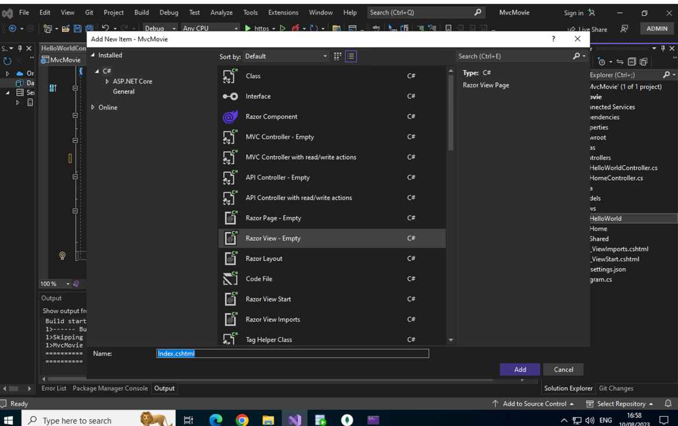

3. Replace the contents of the Views/HelloWorld/Index.cshtml Razor view file with the following:

@{

ViewData["Title"] = "Index";

}

<h2>Index</h2>

<p>Hello from our View Template!</p>

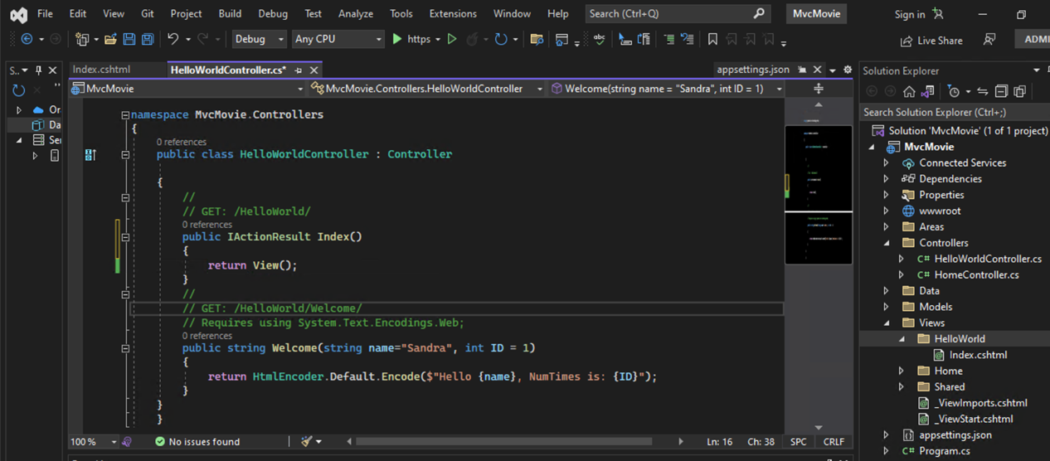

4. The default view has the same name as the action method, Index in this example. The view template /Views/HelloWorld/Index.cshtml is used. The following image shows the string "Hello from our View Template!" hard-coded in the view:

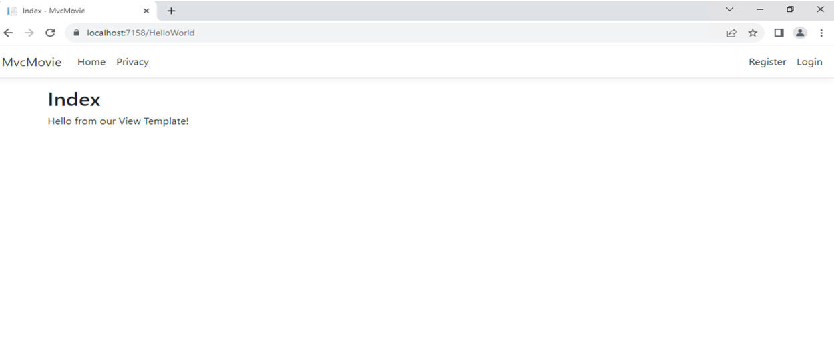

5. Change views and layout pages - Change the title, footer, and menu link in the layout file

* Each page shows the same menu layout. The menu layout is implemented in the Views/Shared/_Layout.cshtml file.
* Open the Views/Shared/_Layout.cshtml file.
* Find the @RenderBody() line. RenderBody is a placeholder where all the view-specific pages you create show up, wrapped in the layout page
* Replace the content of the Views/Shared/_Layout.cshtml file with the following markup. The changes are highlighted:

<!DOCTYPE html>

<html lang="en">

<head>

<meta charset="utf-8" />

<meta name="viewport" content="width=device-width, initial-scale=1.0" />

<title>@ViewData["Title"] - Movie App</title>

<link rel="stylesheet" href="~/lib/bootstrap/dist/css/bootstrap.css" />

<link rel="stylesheet" href="~/css/site.css" asp-append-version="true" />

</head>

<body>

<header>

<nav class="navbar navbar-expand-sm navbar-toggleable-sm navbar-light bg-white border-bottom box-shadow mb-3">

<div class="container-fluid">

<a class="navbar-brand" asp-area="" asp-controller="Movies" asp-action="Index">Movie App</a>

<button class="navbar-toggler" type="button" data-bs-toggle="collapse" data-bs-target=".navbar-collapse" aria-controls="navbarSupportedContent"

aria-expanded="false" aria-label="Toggle navigation">

<span class="navbar-toggler-icon"></span>

</button>

<div class="navbar-collapse collapse d-sm-inline-flex justify-content-between">

<ul class="navbar-nav flex-grow-1">

<li class="nav-item">

<a class="nav-link text-dark" asp-area="" asp-controller="Home" asp-action="Index">Home</a>

</li>

<li class="nav-item">

<a class="nav-link text-dark" asp-area="" asp-controller="Home" asp-action="Privacy">Privacy</a>

</li>

</ul>

</div>

</div>

</nav>

</header>

<div class="container">

<main role="main" class="pb-3">

@RenderBody()

</main>

</div>

<footer class="border-top footer text-muted">

<div class="container">

&copy; 2023 - Movie App - <a asp-area="" asp-controller="Home" asp-action="Privacy">Privacy</a>

</div>

</footer>

<script src="~/lib/jquery/dist/jquery.js"></script>

<script src="~/lib/bootstrap/dist/js/bootstrap.js"></script>

<script src="~/js/site.js" asp-append-version="true"></script>

@await RenderSectionAsync("Scripts", required: false)

</body>

</html>

6.Save the changes and select the **Privacy** link. Notice how the title on the browser tab displays **Privacy Policy - Movie App** instead of **Privacy Policy – MvcMovie**

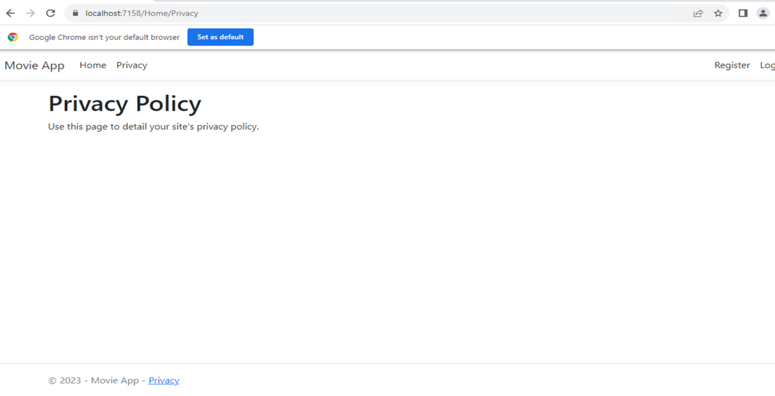

Select the **Home** link.

Notice that the title and anchor text display **Movie App**. The changes were made once in the layout template and all pages on the site reflect the new link text and new title.

* Examine the Views/_ViewStart.cshtml file:

The Views/_ViewStart.cshtml file brings in the Views/Shared/_Layout.cshtml file to each view. The Layout property can be used to set a different layout view

1. Open the Views/HelloWorld/Index.cshtml view file. Change the title and <h2> element as highlighted in the following: Save the change and check the changes https://localhost:{PORT}/HelloWorld.

@{

ViewData["Title"] = "Movie List";

}

<h2>My Movie List</h2>

<p>Hello from our View Template!</p>

## Passing Data from the Controller to the View. In HelloWorldController.cs, change the Welcome method to add a Message and NumTimes value to the ViewData dictionary.

Controllers are responsible for providing the data required in order for a view template to render a response. A view template should work only with the data that's provided to it by the controller.

* The ViewData dictionary is a dynamic object, which means any type can be used. The ViewData object has no defined properties until something is added.

using Microsoft.AspNetCore.Mvc;

using System.Text.Encodings.Web;

namespace MvcMovie.Controllers;

public class HelloWorldController : Controller

{

public IActionResult Index()

{

return View();

}

public IActionResult Welcome(string name, int numTimes = 1)

{

ViewData["Message"] = "Hello " + name;

ViewData["NumTimes"] = numTimes;

return View();

}

}

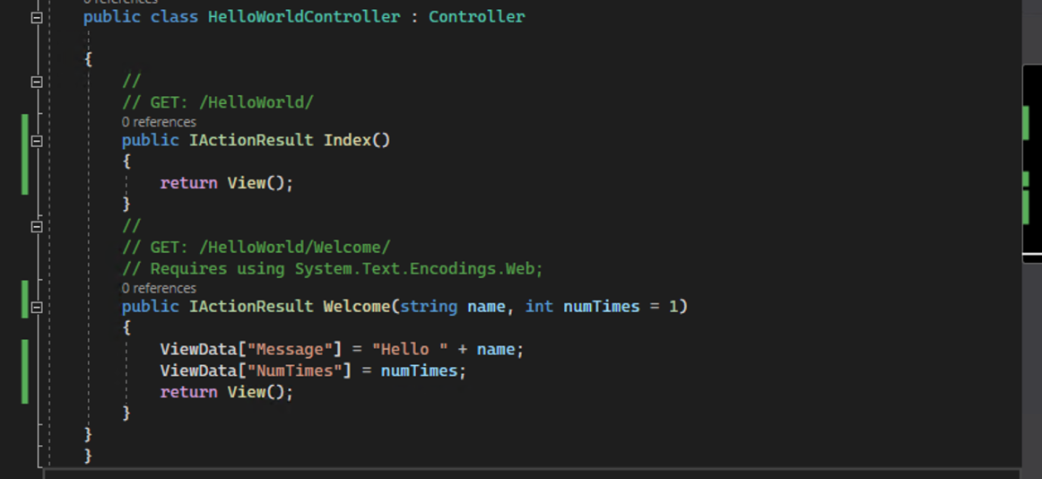

1. Create a Welcome view template named Views/HelloWorld/Welcome.cshtml. Replace the contents of Views/HelloWorld/Welcome.cshtml with the following.

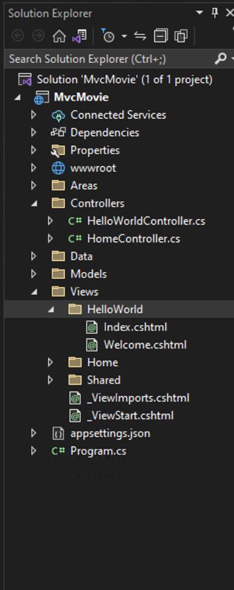

@{

ViewData["Title"] = "Welcome";

}

<h2>Welcome</h2>

<ul>

@for (int i = 0; i < (int)ViewData["NumTimes"]!; i++)

{

<li>@ViewData["Message"]</li>

}

</ul>

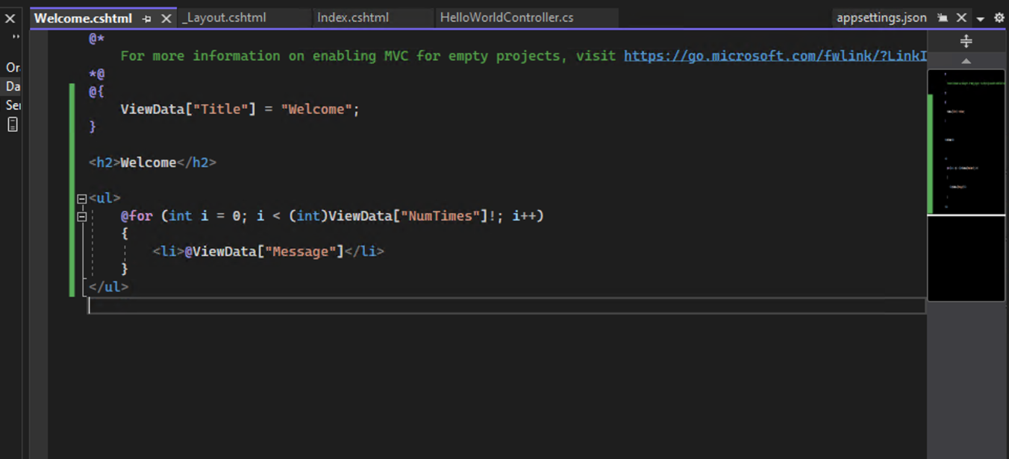

1. Save your changes and browse to the following URL:

[https://localhost:{PORT}/HelloWorld/Welcome?name=Sandra&numtimes=4](https://localhost:%7bPORT%7d/HelloWorld/Welcome?name=Sandra&numtimes=4)

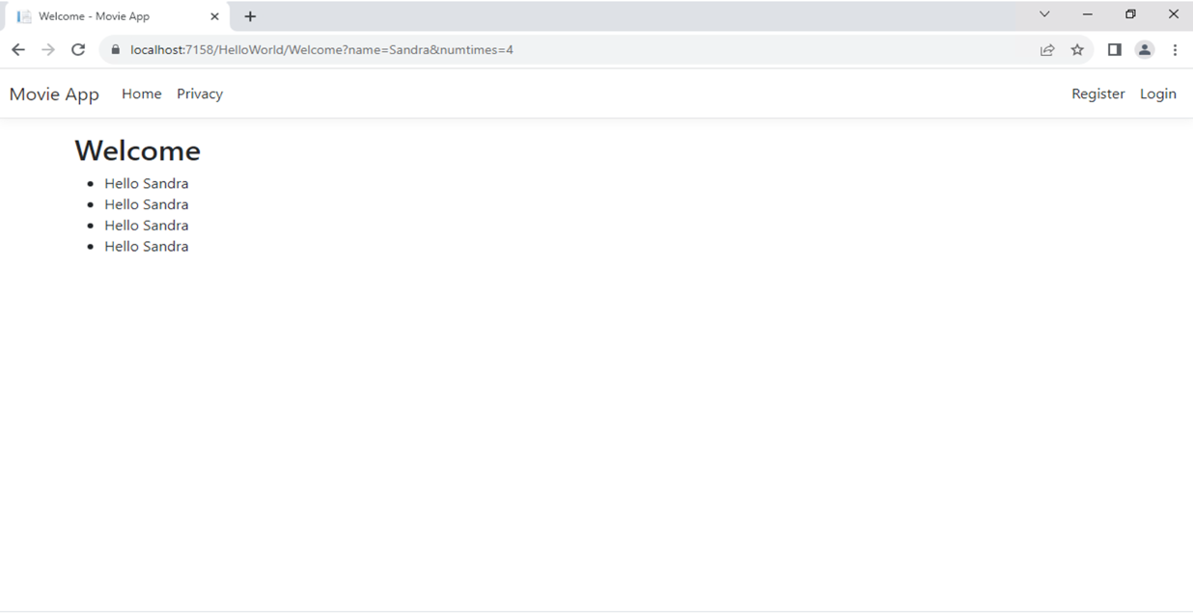

# Part 4, add a model to an ASP.NET Core MVC app

In this tutorial, classes are added for managing movies in a database. These classes are the "**M**odel" part of the **M**VC app.

These model classes are used with Entity Framework Core (EF Core) to work with a database. EF Core is an object-relational mapping (ORM) framework that simplifies the data access code that you have to write.

The model classes created are known as ***POCO*** classes, from **P**lain **O**ld **C**LR **O**bjects. POCO classes don't have any dependency on EF Core. They only define the properties of the data to be stored in the database.

In this tutorial, model classes are created first, and EF Core creates the database.

1. Right-click the Models folder > **Add** > **Class**. Name the file Movie.cs. Update the Models/Movie.cs file with the following code:

using System.ComponentModel.DataAnnotations;

namespace MvcMovie.Models;

public class Movie

{

public int Id { get; set; }

public string? Title { get; set; }

[DataType(DataType.Date)]

public DateTime ReleaseDate { get; set; }

public string? Genre { get; set; }

public decimal Price { get; set; }

}

The question mark after string indicates that the property is nullable. Only the date is displayed, not time information.

2. Scaffold movie pages

Use the scaffolding tool to produce Create, Read, Update, and Delete (CRUD) pages for the movie model.

In **Solution Explorer**, right-click the Controllers folder and select **Add > New Scaffolded Item**.

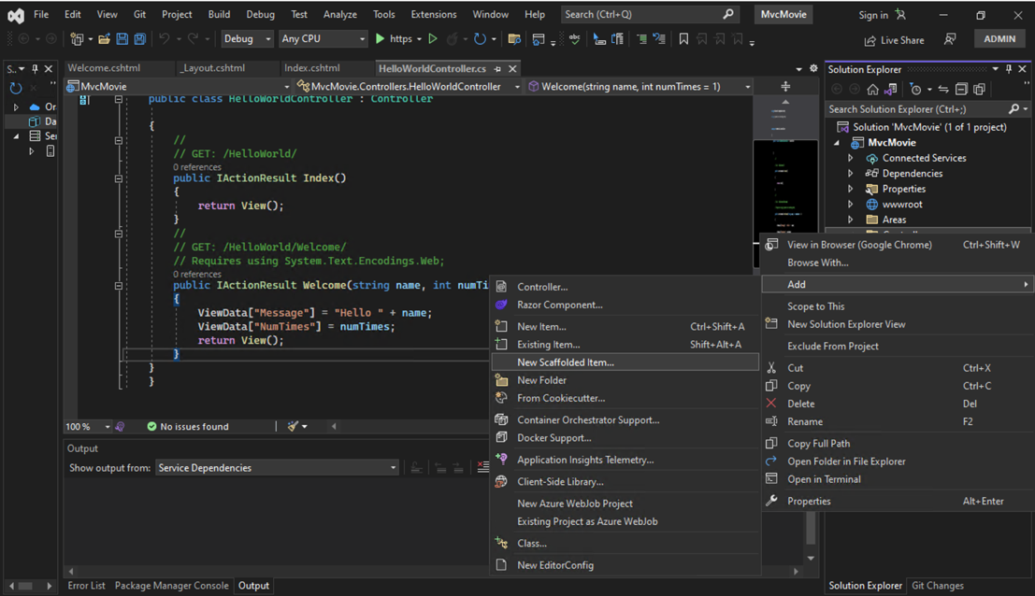

3. In the **Add New Scaffolded Item** dialog:

* In the left pane, select **Installed** > **Common** > **MVC**.
* Select **MVC Controller with views, using Entity Framework**.
* Select **Add**

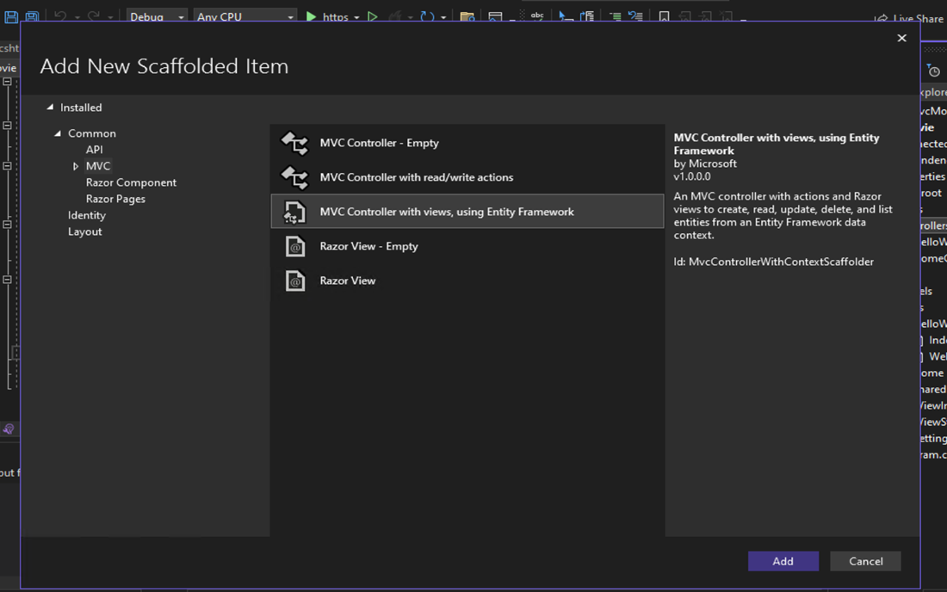

4. Complete the **Add MVC Controller with views, using Entity Framework** dialog:

* In the **Model class** drop down, select **Movie (MvcMovie.Models)**.
* In the **Data context class** row, select the **+** (plus) sign.
  + In the **Add Data Context** dialog, the class name MvcMovie.Data.MvcMovieContext is generated.
  + Select **Add**.
* In the **Database provider** drop down, select **SQL Server**.
* **Views** and **Controller name**: Keep the default.
* Select **Add**.

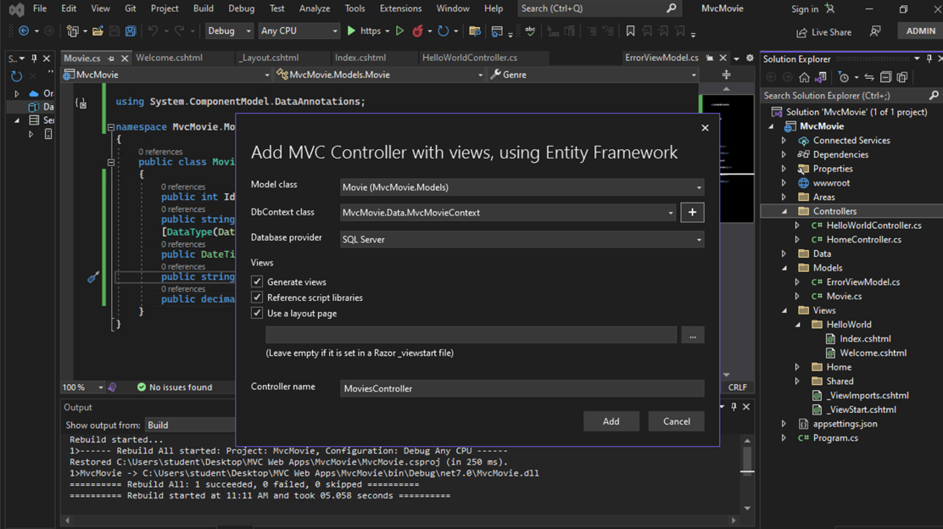

Scaffolding adds the following packages:

* Microsoft.EntityFrameworkCore.SqlServer
* Microsoft.EntityFrameworkCore.Tools
* Microsoft.VisualStudio.Web.CodeGeneration.Design

Scaffolding creates the following:

* A movies controller: Controllers/MoviesController.cs
* Razor view files for **Create**, **Delete**, **Details**, **Edit**, and **Index** pages: Views/Movies/*.cshtml
* A database context class: Data/MvcMovieContext.cs

Scaffolding updates the following:

* Inserts required package references in the MvcMovie.csproj project file.
* Registers the database context in the Program.cs file.
* Adds a database connection string to the appsettings.json file.

The automatic creation of these files and file updates is known as scaffolding.

The scaffolded pages can't be used yet because the database doesn't exist. Running the app and selecting the **Movie App** link results in a Cannot open database or no such table: Movie error message.

Build the app to verify that there are no errors.

## 5. Initial migration

From the **Tools** menu, select **NuGet Package Manager** > **Package Manager Console** .

In the Package Manager Console (PMC), enter the following commands:

Use the EF Core migration  feature to create the database. Migrations is a set of tools that create and update a database to match the data model.

Add-Migration InitialCreate

Update-Database

If you have many databases use - Add-Migration MyMigration -context MvcMovieContext

* Add-Migration InitialCreate: Generates a Migrations/{timestamp}_InitialCreate.cs migration file. The InitialCreate argument is the migration name. Any name can be used, but by convention, a name is selected that describes the migration. Because this is the first migration, the generated class contains code to create the database schema. The database schema is based on the model specified in the MvcMovieContext class.
* Update-Database: Updates the database to the latest migration, which the previous command created. This command runs the Up method in the Migrations/{time-stamp}_InitialCreate.cs file, which creates the database.

The Update-Database command generates the following warning:

No type was specified for the decimal column 'Price' on entity type 'Movie'. This will cause values to be silently truncated if they do not fit in the default precision and scale. Explicitly specify the SQL server column type that can accommodate all the values using 'HasColumnType()'.

## 7. Test the app

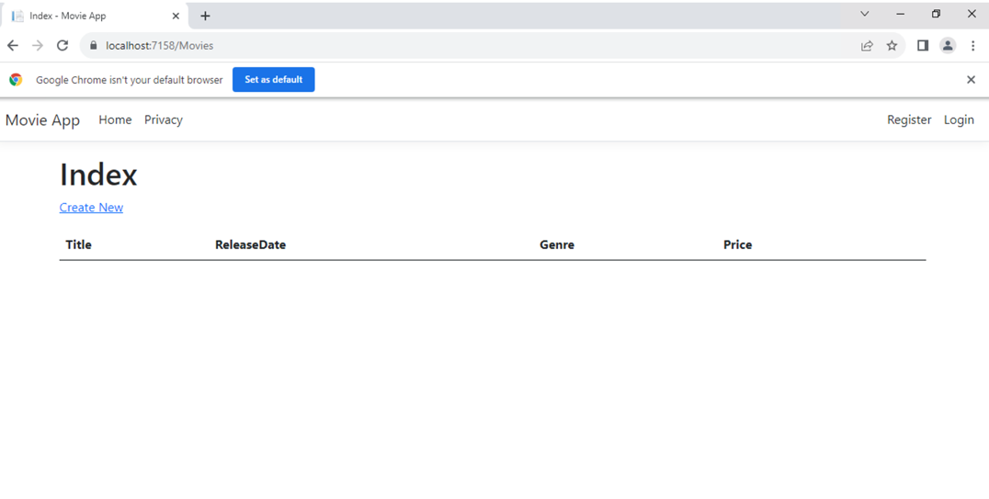

# Part 5, work with a database in an ASP.NET Core MVC app

## SQL Server Express LocalDB

LocalDB:

* Is a lightweight version of the SQL Server Express Database Engine, installed by default with Visual Studio.
* Starts on demand by using a connection string.
* Is targeted for program development. It runs in user mode, so there's no complex configuration.

The MvcMovieContext object handles the task of connecting to the database and mapping Movie objects to database records. The database context is registered with the container in the Program.cs file: The ASP.NET Core configuration  system reads the ConnectionString key. For local development, it gets the connection string from the appsettings.json file:

"ConnectionStrings": {

"MvcMovieContext": "Server=(localdb)\\mssqllocaldb;Database=MvcMovieContext-7dc5;Trusted_Connection=True;MultipleActiveResultSets=true"

}

1.Examine the Database

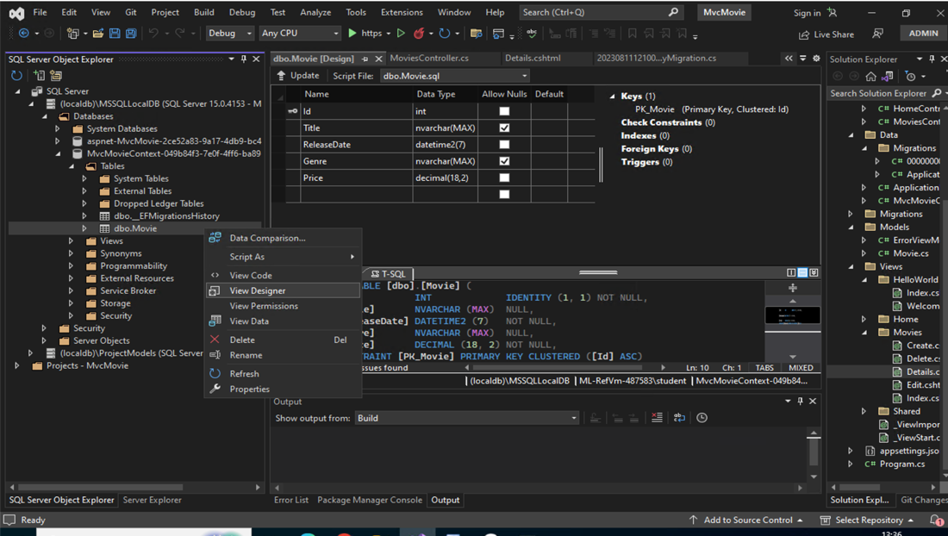

2. Seed the Database

If there are any movies in the database, the seed initializer returns, and no movies are added.

using Microsoft.EntityFrameworkCore;

using Microsoft.Extensions.DependencyInjection;

using MvcMovie.Data;

using System;

using System.Linq;

namespace MvcMovie.Models;

public static class SeedData

{

public static void Initialize(IServiceProvider serviceProvider)

{

using (var context = new MvcMovieContext(

serviceProvider.GetRequiredService<

DbContextOptions<MvcMovieContext>>()))

{

// Look for any movies.

if (context.Movie.Any())

{

return; // DB has been seeded

}

context.Movie.AddRange(

new Movie

{

Title = "When Harry Met Sally",

ReleaseDate = DateTime.Parse("1989-2-12"),

Genre = "Romantic Comedy",

Price = 7.99M

},

new Movie

{

Title = "Ghostbusters ",

ReleaseDate = DateTime.Parse("1984-3-13"),

Genre = "Comedy",

Price = 8.99M

},

new Movie

{

Title = "Ghostbusters 2",

ReleaseDate = DateTime.Parse("1986-2-23"),

Genre = "Comedy",

Price = 9.99M

},

new Movie

{

Title = "Rio Bravo",

ReleaseDate = DateTime.Parse("1959-4-15"),

Genre = "Western",

Price = 3.99M

}

);

context.SaveChanges();

}

}

}

### 3. Add the seed initializer

Replace the contents of Program.cs with the following code. The new code is highlighted.

using Microsoft.EntityFrameworkCore;

using Microsoft.Extensions.DependencyInjection;

using MvcMovie.Data;

using MvcMovie.Models;

var builder = WebApplication.CreateBuilder(args);

builder.Services.AddDbContext<MvcMovieContext>(options =>

options.UseSqlServer(builder.Configuration.GetConnectionString("MvcMovieContext")));

// Add services to the container.

builder.Services.AddControllersWithViews();

var app = builder.Build();

using (var scope = app.Services.CreateScope())

{

var services = scope.ServiceProvider;

SeedData.Initialize(services);

}

// Configure the HTTP request pipeline.

if (!app.Environment.IsDevelopment())

{

app.UseExceptionHandler("/Home/Error");

// The default HSTS value is 30 days. You may want to change this for production scenarios, see https://aka.ms/aspnetcore-hsts.

app.UseHsts();

}

app.UseHttpsRedirection();

app.UseStaticFiles();

app.UseRouting();

app.UseAuthorization();

app.MapControllerRoute(

name: "default",

pattern: "{controller=Home}/{action=Index}/{id?}");

app.Run();

4. Test the app. Force the app to initialize, calling the code in the Program.cs file, so the seed method runs.

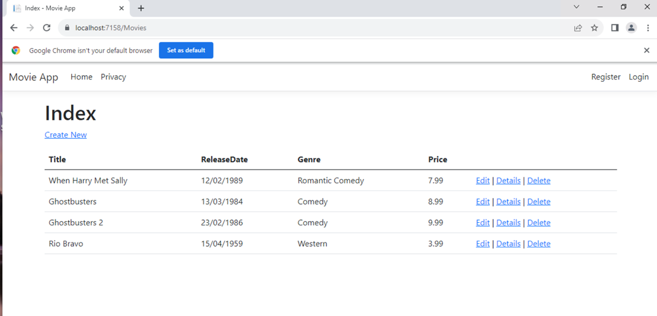

# Part 6, controller methods and views in ASP.NET Core

We have a good start to the movie app, but the presentation isn't ideal, for example, ReleaseDate should be two words.

1. Open the Models/Movie.cs file and add the highlighted lines shown below:

using System;

using System.ComponentModel.DataAnnotations;

using System.ComponentModel.DataAnnotations.Schema;

namespace MvcMovie.Models;

public class Movie

{

public int Id { get; set; }

public string? Title { get; set; }

[Display(Name = "Release Date")]

[DataType(DataType.Date)]

public DateTime ReleaseDate { get; set; }

public string? Genre { get; set; }

[Column(TypeName = "decimal(18, 2)")]

public decimal Price { get; set; } }

Now check Movie page again.

2.The **Edit**, **Details**, and **Delete** links are generated by the Core MVC Anchor Tag Helper in the Views/Movies/Index.cshtml file. Observe Index.cshtml.

3. Set the home page - Recall the format for routing set in the Program.cs file: The following Programe.cs calls Books controller that was create later. Instead you can call movies.

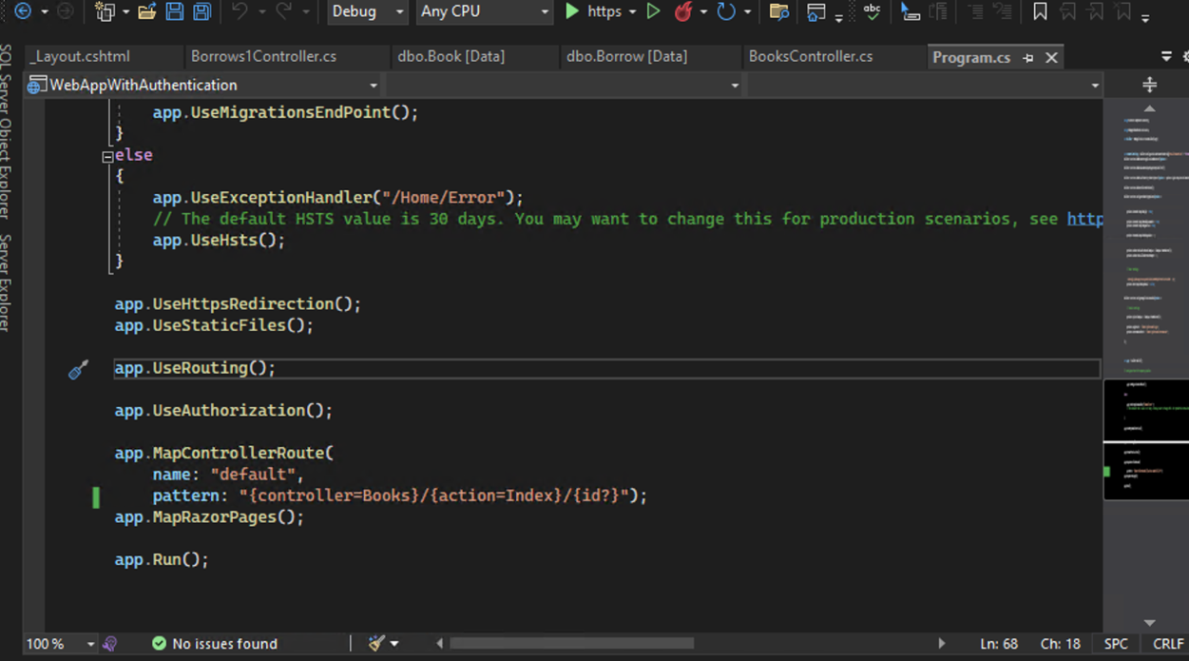

When the scaffolding system created the Edit view, it examined the Movie class and created code to render <label> and <input> elements for each property of the class.

4. Observe the Views/Movies/Edit.cshtml

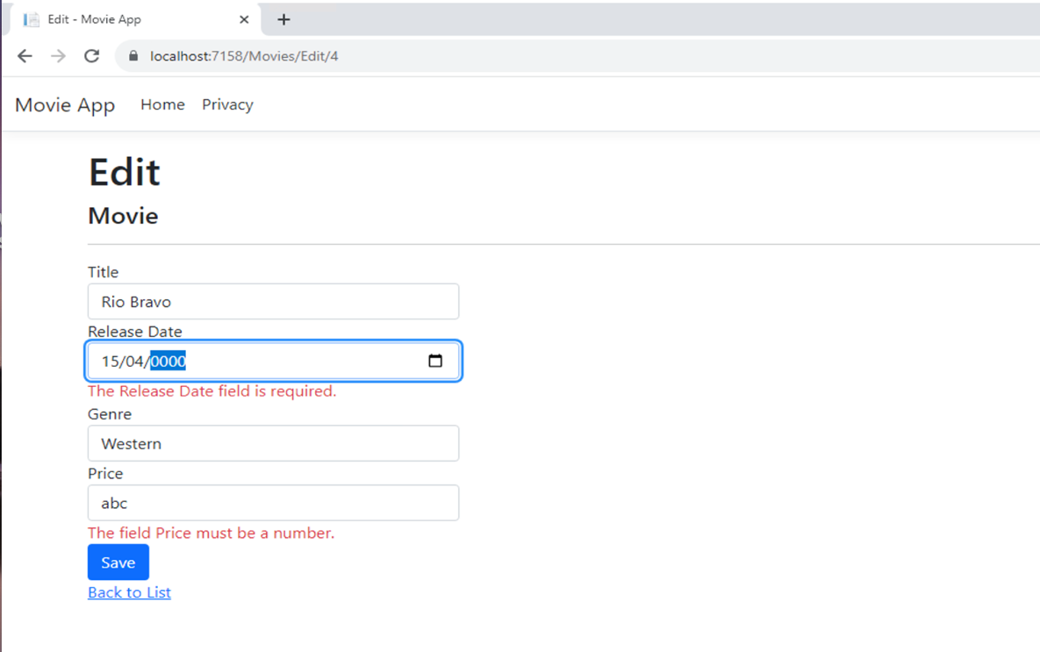

Notice how the view template has a @model MvcMovie.Models.Movie statement at the top of the file. @model MvcMovie.Models.Movie specifies that the view expects the model for the view template to be of type Movie.

The model binding  system takes the posted form values and creates a Movie object that's passed as the movie parameter. The ModelState.IsValid property verifies that the data submitted in the form can be used to modify (edit or update) a Movie object. If the data is valid, it's saved. The updated (edited) movie data is saved to the database by calling the SaveChangesAsync method of database context. After saving the data, the code redirects the user to the Index action method of the MoviesController class, which displays the movie collection.

# Part 7, add search to an ASP.NET Core MVC app

In this section, you add search capability to the Index action method that lets you search movies by genre or name.

1. Update the Index method found inside Controllers/MoviesController.cs with the following code:

public async Task<IActionResult> Index(string searchString)

{

if (_context.Movie == null)

{

return Problem("Entity set 'MvcMovieContext.Movie' is null.");

}

var movies = from m in _context.Movie

select m;

if (!String.IsNullOrEmpty(searchString))

{

movies = movies.Where(s => s.Title!.Contains(searchString));

}

return View(await movies.ToListAsync()); }

The following line in the Index action method creates a [LINQ](https://learn.microsoft.com/en-us/dotnet/standard/using-linq) query to select the movies:

var movies = from m in _context.Movie

select m;

If the searchString parameter contains a string, the movies query is modified to filter on the value of the search string:

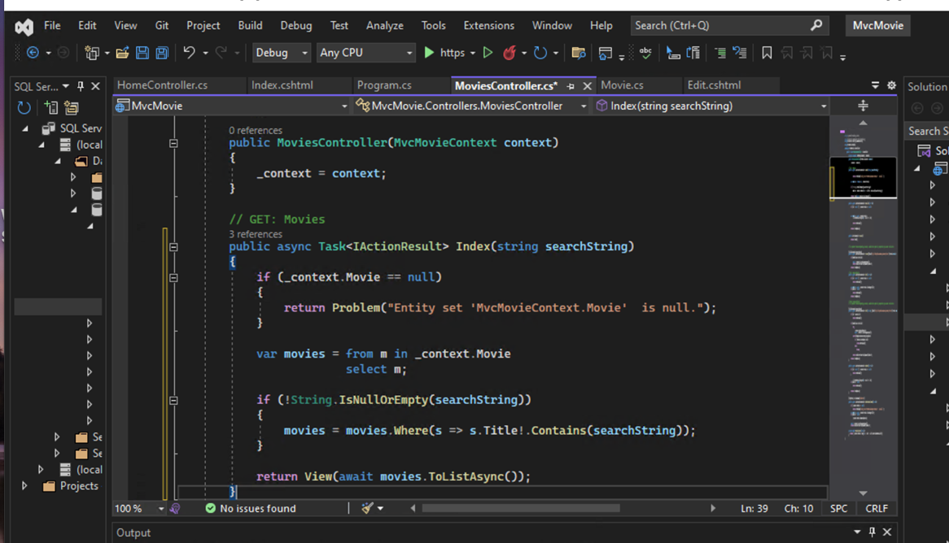

2. Open the Views/Movies/Index.cshtml file, and add the <form> markup highlighted below:

@model IEnumerable<MvcMovie.Models.Movie>

@{

ViewData["Title"] = "Index";

}

<h2>Index</h2>

<p>

<a asp-action="Create">Create New</a>

</p>

<form asp-controller="Movies" asp-action="Index">

<p>

Title: <input type="text" name="SearchString" />

<input type="submit" value="Filter" />

</p>

</form>

3. Run and check the application

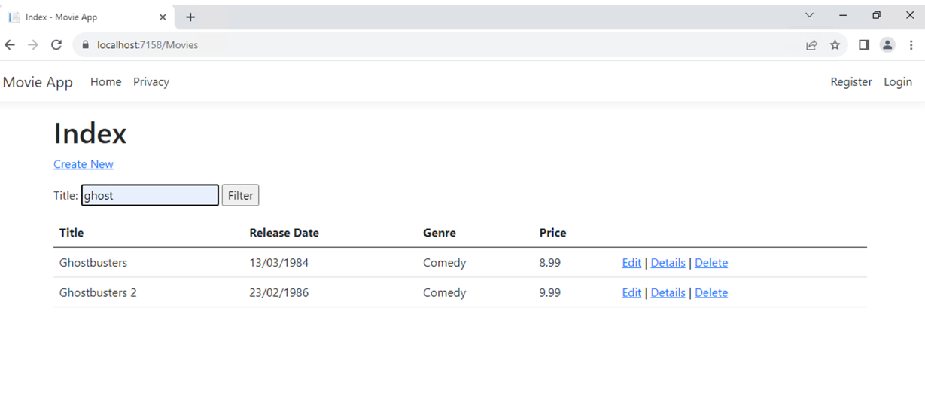

## 4. Add Search by genre

Add the following MovieGenreViewModel class to the Models folder:

using Microsoft.AspNetCore.Mvc.Rendering;

using System.Collections.Generic;

namespace MvcMovie.Models;

public class MovieGenreViewModel

{

public List<Movie>? Movies { get; set; }

public SelectList? Genres { get; set; }

public string? MovieGenre { get; set; }

public string? SearchString { get; set; }

}

5. Replace the Index method in MoviesController.cs with the following code:

// GET: Movies

public async Task<IActionResult> Index(string movieGenre, string searchString)

{

if (_context.Movie == null)

{

return Problem("Entity set 'MvcMovieContext.Movie' is null.");

}

// Use LINQ to get list of genres.

IQueryable<string> genreQuery = from m in _context.Movie

orderby m.Genre

select m.Genre;

var movies = from m in _context.Movie

select m;

if (!string.IsNullOrEmpty(searchString))

{

movies = movies.Where(s => s.Title!.Contains(searchString));

}

if (!string.IsNullOrEmpty(movieGenre))

{

movies = movies.Where(x => x.Genre == movieGenre);

}

var movieGenreVM = new MovieGenreViewModel

{

Genres = new SelectList(await genreQuery.Distinct().ToListAsync()),

Movies = await movies.ToListAsync()

};

return View(movieGenreVM);

}

## 6. Add search by genre to the Index view

Update Index.cshtml found in Views/Movies/ as follows:

@model MvcMovie.Models.MovieGenreViewModel

@{

ViewData["Title"] = "Index";

}

<h1>Index</h1>

<p>

<a asp-action="Create">Create New</a>

</p>

<form asp-controller="Movies" asp-action="Index" method="get">

<p>

<select asp-for="MovieGenre" asp-items="Model.Genres">

<option value="">All</option>

</select>

Title: <input type="text" asp-for="SearchString" />

<input type="submit" value="Filter" />

</p>

</form>

<table class="table">

<thead>

<tr>

<th>

@Html.DisplayNameFor(model => model.Movies![0].Title)

</th>

<th>

@Html.DisplayNameFor(model => model.Movies![0].ReleaseDate)

</th>

<th>

@Html.DisplayNameFor(model => model.Movies![0].Genre)

</th>

<th>

@Html.DisplayNameFor(model => model.Movies![0].Price)

</th>

<th></th>

</tr>

</thead>

<tbody>

@foreach (var item in Model.Movies!)

{

<tr>

<td>

@Html.DisplayFor(modelItem => item.Title)

</td>

<td>

@Html.DisplayFor(modelItem => item.ReleaseDate)

</td>

<td>

@Html.DisplayFor(modelItem => item.Genre)

</td>

<td>

@Html.DisplayFor(modelItem => item.Price)

</td>

<td>

<a asp-action="Edit" asp-route-id="@item.Id">Edit</a> |

<a asp-action="Details" asp-route-id="@item.Id">Details</a> |

<a asp-action="Delete" asp-route-id="@item.Id">Delete</a>

</td>

</tr>

}

</tbody>

</table>

7. Run the Web App

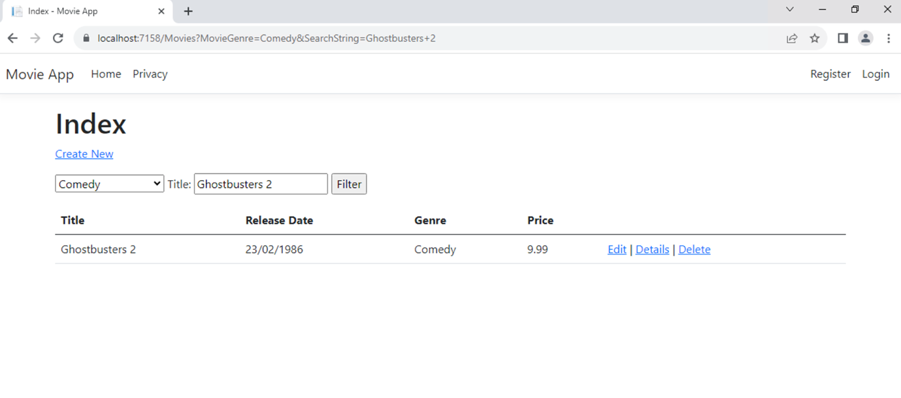

# Part 8, add a new field to an ASP.NET Core MVC app

In this section Entity Framework  Code First Migrations is used to:

* Add a new field to the model.
* Migrate the new field to the database.

When EF Code First is used to automatically create a database, Code First:

* Adds a table to the database to track the schema of the database.
* Verifies the database is in sync with the model classes it was generated from. If they aren't in sync, EF throws an exception. This makes it easier to find inconsistent database/code issues.

1. Add a Rating property to Models/Movie.cs:

using System;

using System.ComponentModel.DataAnnotations;

using System.ComponentModel.DataAnnotations.Schema;

namespace MvcMovie.Models;

public class Movie

{

public int Id { get; set; }

public string? Title { get; set; }

[Display(Name = "Release Date")]

[DataType(DataType.Date)]

public DateTime ReleaseDate { get; set; }

public string? Genre { get; set; }

[Column(TypeName = "decimal(18, 2)")]

public decimal Price { get; set; }

public string? Rating { get; set; }

}

2. Because you've added a new field to the Movie class, you need to update the property binding list so this new property will be included. In MoviesController.cs, update the [Bind] attribute for both the Create and Edit action methods to include the Rating property:

[Bind("Id,Title,ReleaseDate,Genre,Price,Rating")]

3. Update the view templates in order to display, create, and edit the new Rating property in the browser view. Edit the /Views/Movies/Index.cshtml file and add a Rating field:

<table class="table">

<thead>

<tr>

<th>

@Html.DisplayNameFor(model => model.Movies[0].Title)

</th>

<th>

@Html.DisplayNameFor(model => model.Movies[0].ReleaseDate)

</th>

<th>

@Html.DisplayNameFor(model => model.Movies[0].Genre)

</th>

<th>

@Html.DisplayNameFor(model => model.Movies[0].Price)

</th>

<th>

@Html.DisplayNameFor(model => model.Movies[0].Rating)

</th>

<th></th>

</tr>

</thead>

<tbody>

@foreach (var item in Model.Movies)

{

<tr>

<td>

@Html.DisplayFor(modelItem => item.Title)

</td>

<td>

@Html.DisplayFor(modelItem => item.ReleaseDate)

</td>

<td>

@Html.DisplayFor(modelItem => item.Genre)

</td>

<td>

@Html.DisplayFor(modelItem => item.Price)

</td>

<td>

@Html.DisplayFor(modelItem => item.Rating)

</td>

<td>

<a asp-action="Edit" asp-route-id="@item.Id">Edit</a> |

<a asp-action="Details" asp-route-id="@item.Id">Details</a> |

<a asp-action="Delete" asp-route-id="@item.Id">Delete</a>

</td>

</tr>

}

</tbody>\

</table>

4. Update /views/Movies/Create.cshtml with a rating field

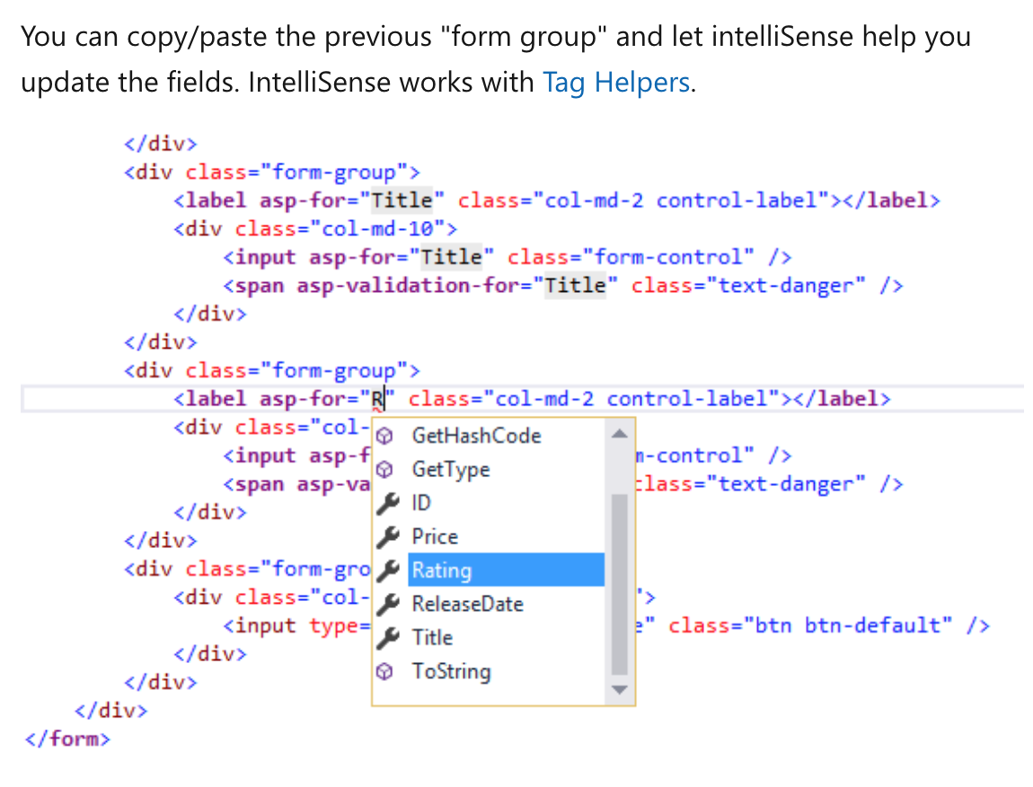

5. Update the remaining templates.

Update the SeedData class so that it provides a value for the new column. A sample change is shown below, but you'll want to make this change for each new Movie.

new Movie

{

Title = "When Harry Met Sally",

ReleaseDate = DateTime.Parse("1989-1-11"),

Genre = "Romantic Comedy",

Rating = "R",

Price = 7.99M

},

6.Use Code First Migrations to update the database schema.

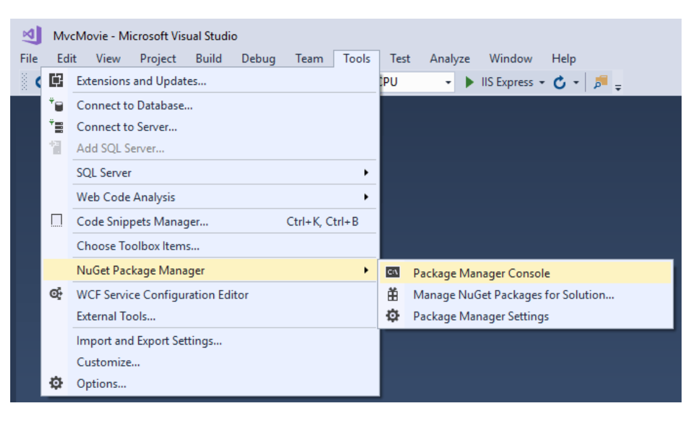

Add-Migration Rating

Update-Database

Or use

Add-Migration Rating -context MvcMovieContext

Update-Database

7. Run the application and check your changes

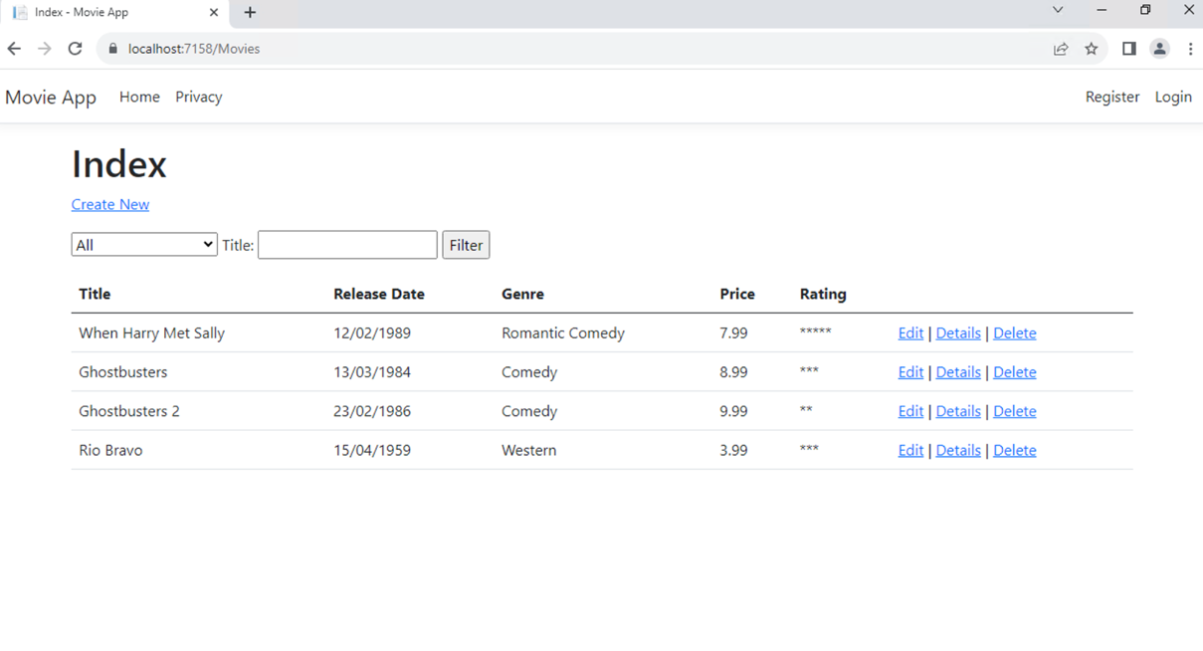

# Part 9, add validation to an ASP.NET Core MVC app

Update the Movie class to take advantage of the built-in validation attributes Required, StringLength, RegularExpression, Range and the DataType formatting attribute.

The validation attributes specify behavior that you want to enforce on the model properties they're applied to:

* The Required and MinimumLength attributes indicate that a property must have a value; but nothing prevents a user from entering white space to satisfy this validation.
* The RegularExpression attribute is used to limit what characters can be input. In the preceding code, "Genre":
  + Must only use letters.
  + The first letter is required to be uppercase. White spaces are allowed while numbers, and special characters are not allowed.
* The RegularExpression "Rating":
  + Requires that the first character be an uppercase letter.
  + Allows special characters and numbers in subsequent spaces. "PG-13" is valid for a rating, but fails for a "Genre".
* The Range attribute constrains a value to within a specified range.
* The StringLength attribute lets you set the maximum length of a string property, and optionally its minimum length.
* Value types (such as decimal, int, float, DateTime) are inherently required and don't need the [Required] attribute.

Having validation rules automatically enforced by ASP.NET Core helps make your app more robust. It also ensures that you can't forget to validate something and inadvertently let bad data into the database.

1.Update the Movie class to take advantage of the built-in validation attributes Required, StringLength, RegularExpression, Range and the DataType formatting attribute.

using System;

using System.ComponentModel.DataAnnotations;

using System.ComponentModel.DataAnnotations.Schema;

namespace MvcMovie.Models;

public class Movie

{

public int Id { get; set; }

[StringLength(60, MinimumLength = 3)]

[Required]

public string? Title { get; set; }

[Display(Name = "Release Date")]

[DataType(DataType.Date)]

public DateTime ReleaseDate { get; set; }

[Range(1, 100)]

[DataType(DataType.Currency)]

[Column(TypeName = "decimal(18, 2)")]

public decimal Price { get; set; }

[RegularExpression(@"^[A-Z]+[a-zA-Z\s]*$")]

[Required]

[StringLength(30)]

public string? Genre { get; set; }

[RegularExpression(@"^[A-Z]+[a-zA-Z0-9""'\s-]*$")]

[StringLength(5)]

[Required]

public string? Rating { get; set; }

}

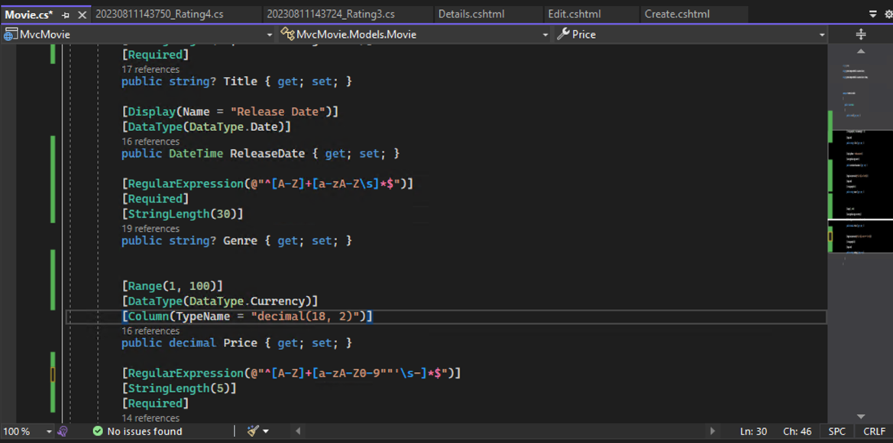

2. Run the app and navigate to the Movies controller.

Select the **Create New** link to add a new movie. Fill out the form with some invalid values. As soon as jQuery client side validation detects the error, it displays an error message.

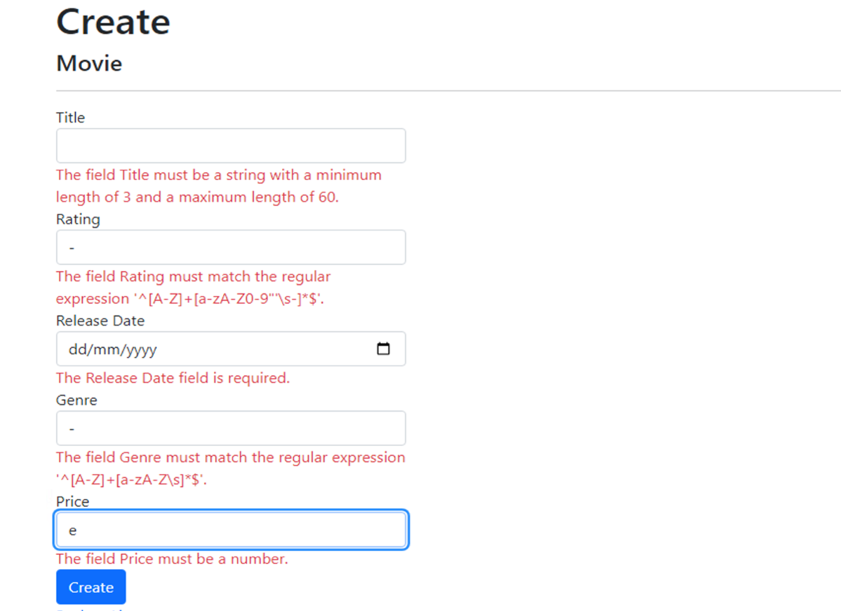

# Part 10, examine the Details and Delete methods

1. Open the Movie controller and examine the Details method:

The MVC scaffolding engine that created this action method adds a comment showing an HTTP request that invokes the method. In this case it's a GET request with three URL segments, the Movies controller, the Details method, and an id value. Recall these segments are defined in Program.cs.

EF makes it easy to search for data using the FirstOrDefaultAsync method. An important security feature built into the method is that the code verifies that the search method has found a movie before it tries to do anything with it. For example, a hacker could introduce errors into the site by changing the URL created by the links from http://localhost:{PORT}/Movies/Details/1 to something like http://localhost:{PORT}/Movies/Details/12345 (or some other value that doesn't represent an actual movie). If you didn't check for a null movie, the app would throw an exception.

2. Examine the Delete and DeleteConfirmed methods.

Note that the HTTP GET Delete method doesn't delete the specified movie, it returns a view of the movie where you can submit (HttpPost) the deletion. Performing a delete operation in response to a GET request (or for that matter, performing an edit operation, create operation, or any other operation that changes data) opens up a security hole.

The [HttpPost] method that deletes the data is named DeleteConfirmed to give the HTTP POST method a unique signature or name.

# Part 11 Simple authorization in ASP.NET Core

The AuthorizeAttribute  can ***not*** be applied to Razor Page handlers. For example, [Authorize] can't be applied to OnGet, OnPost, or any other page handler. Consider using an ASP.NET Core MVC controller for pages with different authorization requirements for different handlers. Using an MVC controller when different authorization requirements are required:

* Is the least complex approach.
* Is the approach recommended by Microsoft.

1. If you have created the App with ‘individual authentication, the required classes are already created. Create identity is already in the data/migration folder. Observe the class.

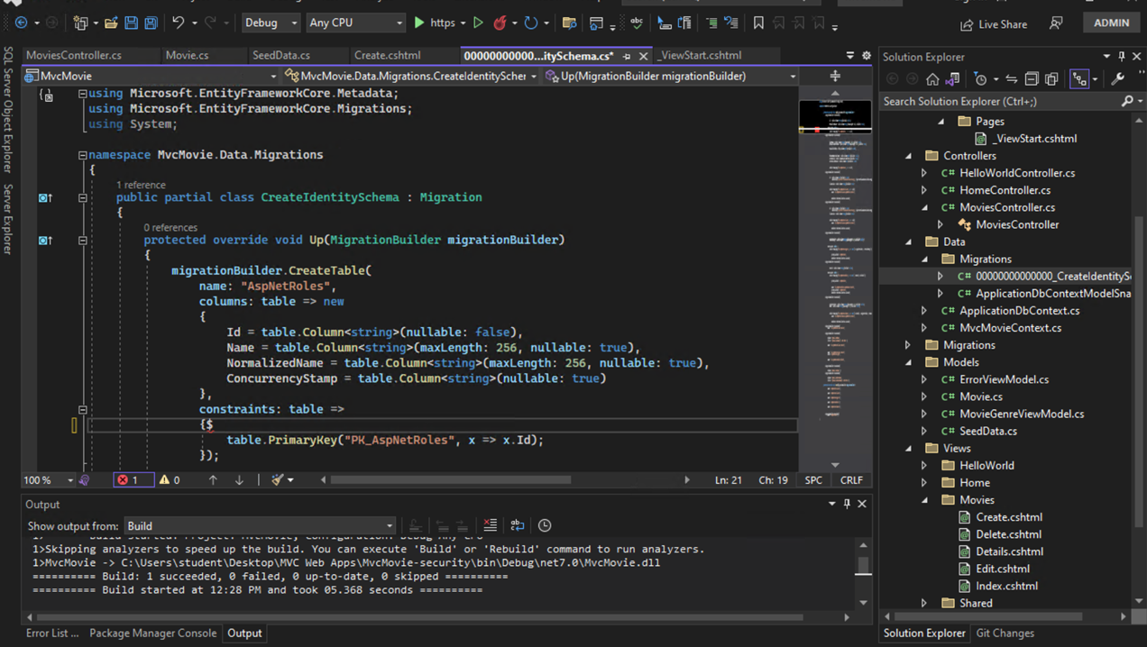

2. Run the app and activate identity object by ‘registering’ a user. This activates SQL Server aspnet user database.

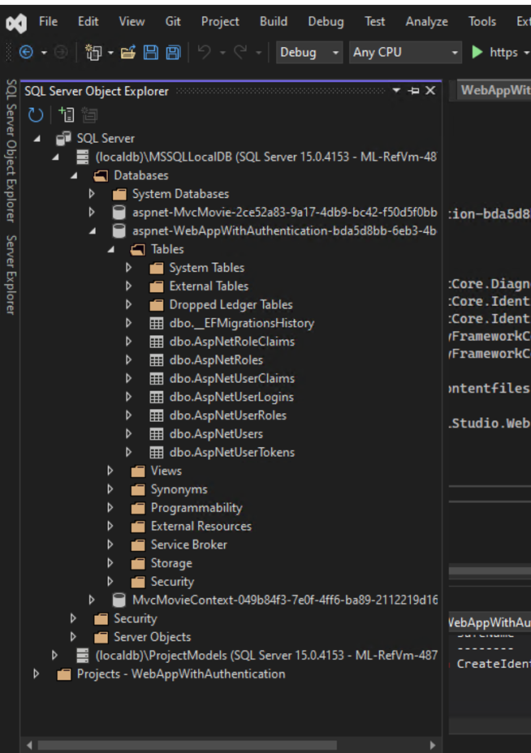

3. Ok, you have WebApp users . Now you can either use restricted access to the whole controller class or individual methods. Observe, the attribute [Authorize] is place on top of create view call. So unauthorised users should not be able to see the create view.

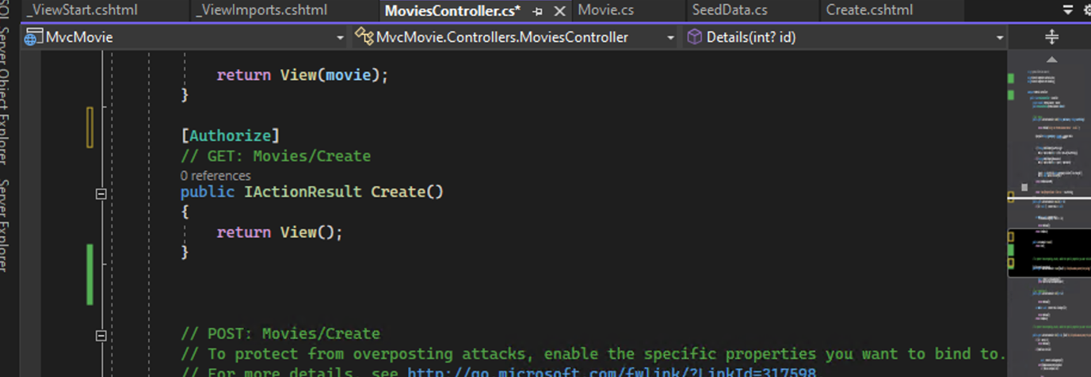

4. Run the application and call create movie link. It should prompt with login page for unauthorised users whereas authorised users can see the create view.

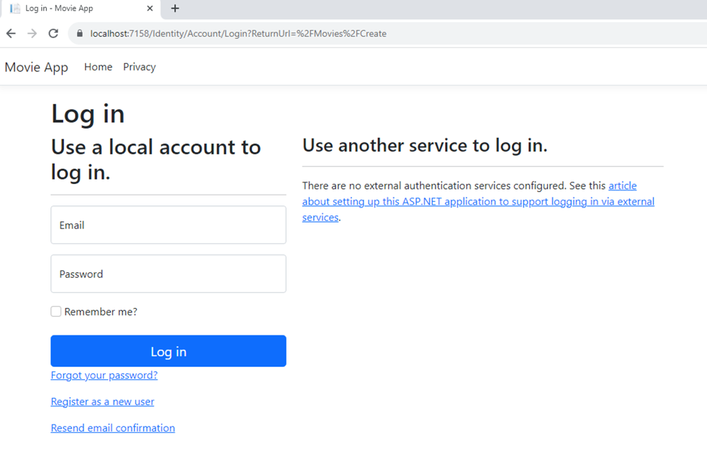

5. Observe you can also add the following tag to methods for anonymous users.

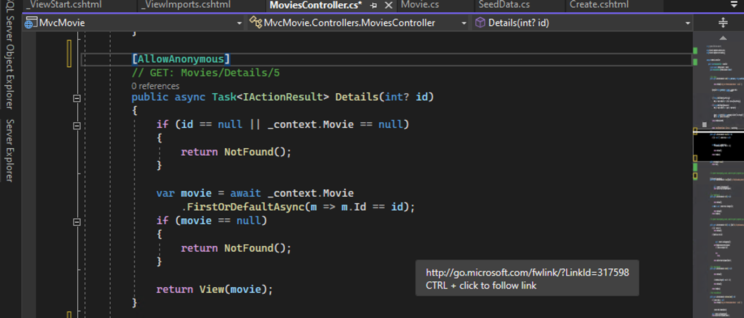

# Part 12, Scaffold Identity into a Razor project

Suppose you create a ‘individual security web app’ want to see all your identity classes in the solution explore. Before you create your business tables, activate identity classes using scaffolded items.

1. Create a new Web App
2. From **Solution Explorer**, right-click on the project > **Add** > **New Scaffolded Item**.
3. From the left pane of the **Add New Scaffolded Item** dialog, select **Identity**. Select **Identity** in the center pane. Select the **Add** button.

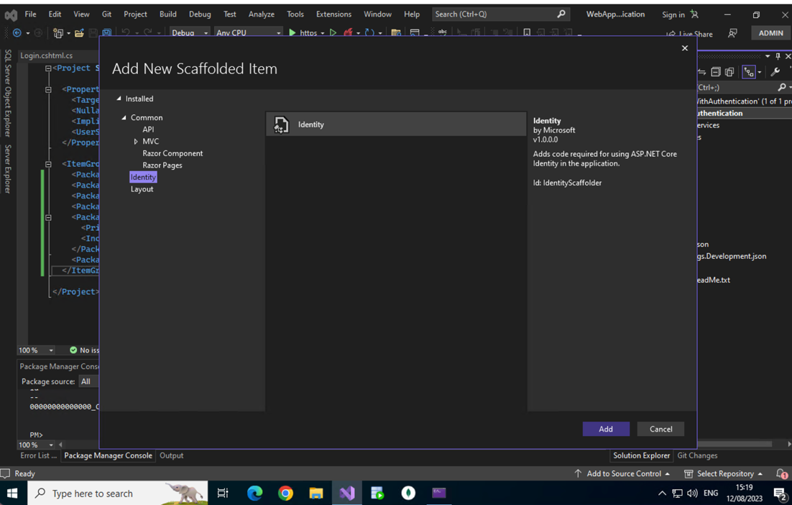

1. In the **Add Identity** dialog, select the options you want.
   * If you have an existing, customized layout page for Identity (_Layout.cshtml), select your existing layout page to avoid overwriting your layout with incorrect markup by the scaffolder. For example, select either:
     + Pages/Shared/_Layout.cshtml for Razor Pages or Blazor Server projects with existing Razor Pages infrastructure.
     + Views/Shared/_Layout.cshtml for MVC projects or Blazor Server projects with existing MVC infrastructure.
   * For the data context (**DbContext class**):
     + Select your data context class. You must select at least one file to add your data context.
     + To create a data context and possibly create a new user class for Identity, select the **+** button. Accept the default value or specify a class (for example, Contoso.Data.ApplicationDbContext for a company named "Contoso"). To create a new user class, select the **+** button for **User class** and specify the class (for example, ContosoUser for a company named "Contoso").
   * Select the **Add** button to run the scaffolder.

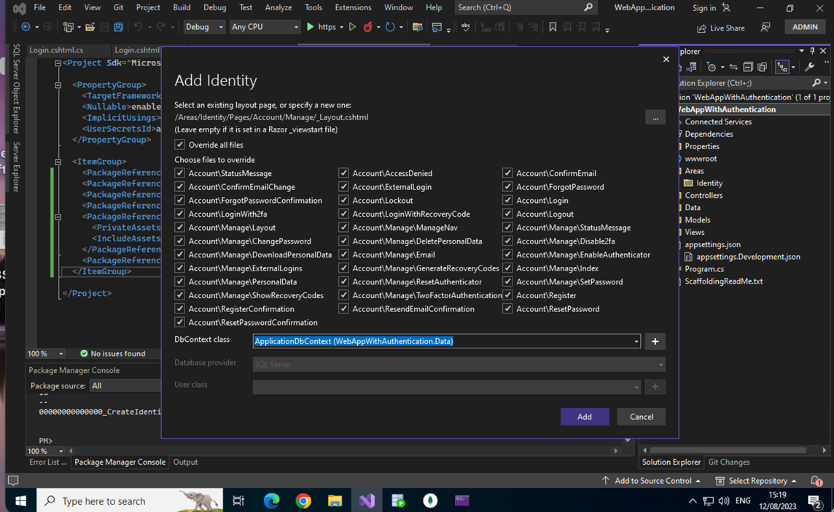

1. The generated Identity database code requiresEF Core migration.

Install-Package Microsoft.AspNetCore.Diagnostics.EntityFrameworkCore

Add-Migration CreateIdentitySchema

Update-Database

If the Identity schema has already been created but not applied to the database, only the command to update the database must be executed:

Update-Database

You can confirm the application of an Identity schema with the following command. The output of the command includes an "applied" column to show which migrations are applied to the database.

Get-Migration

6.Check if you can see all the identity classes in ‘Areas/identify/Accounts’ folder in solution explorer.

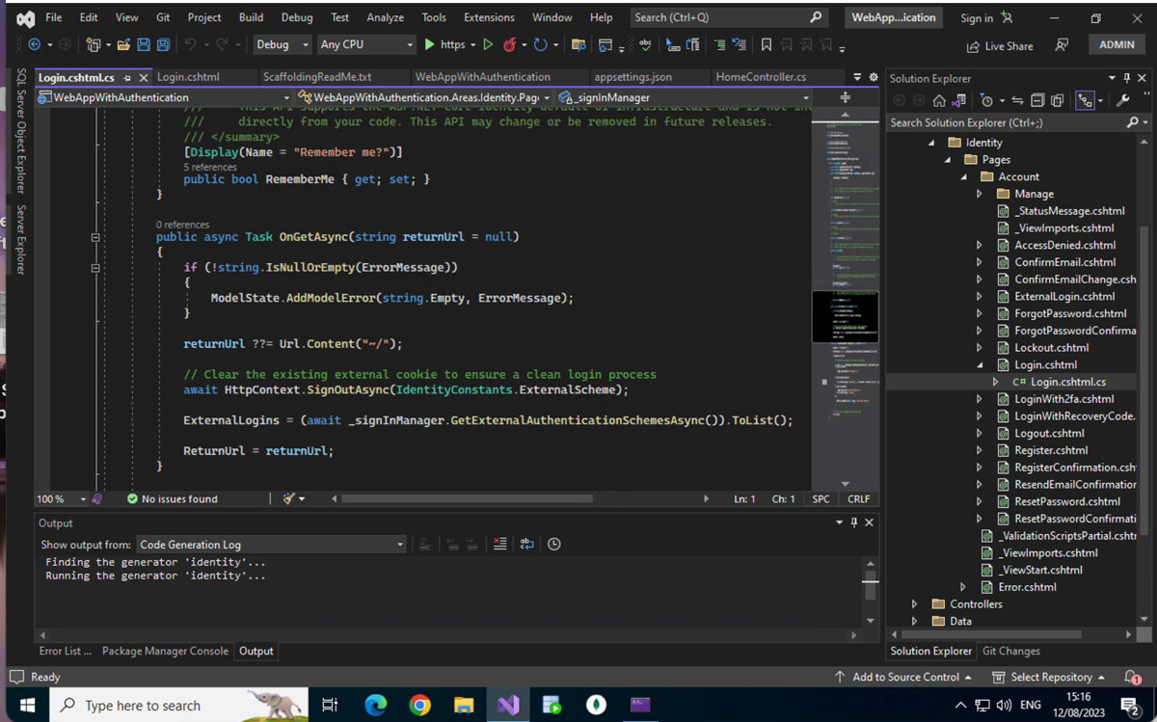

* 1. Run the application and create users. Check your records in the local DB

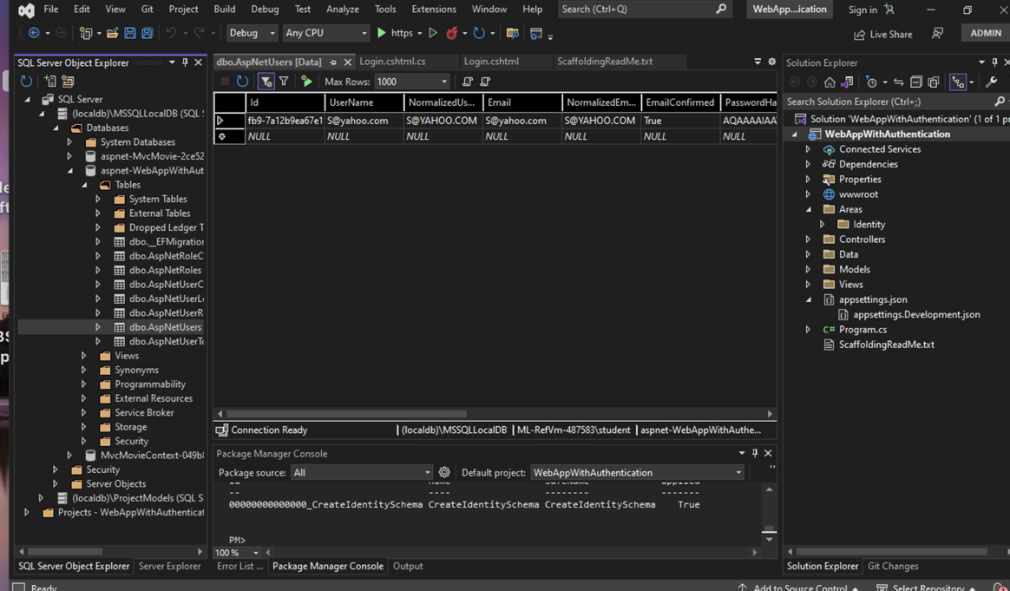

# Reference

The content is built using the Microsoft ASP.NET Documentation

<https://learn.microsoft.com/en-us/aspnet/core/?view=aspnetcore-7.0>